Helping with reading at home

- When you are reading with your child,
model how a good reader reads.

- Encourage your child to use their knowledge
of sounds to help them read unknown words.
In words with 4 or 5 sounds, such as s-t-a-n-d, your child may find it hard to blend and will need lots of practice!

The boy can run f-a-s-t.

- When your child encounters longer words
which they don’t know encourage him/her
to read them syllable by syllable.

- Reading is concerned with seeking meaning. Children should continually reflect on what
they are reading, relating it to their own
experiences, making connections, questioning,
making sense.

- Reinforce positive attempts.

- Reading should always be an enjoyable activity.

- Have fun!

Linguistic Phonics


p-l-u-m

Helping your child with reading
and writing at home

Linguistic Phonics

Linguistic Phonics helps children understand how the print code in English works. It is an integrated approach, providing children with strategies to help them problem-solve words for both reading and writing.

There are five principles that underpin Linguistic Phonics:

  - sounds are represented by letters

  - longer words are made up of syllables

  - a sound may be presented by one or more letter

  - the same sound can be represented in more than one way

  - the same spelling may represent more than one sound

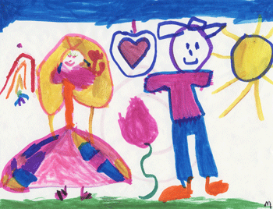
my mum and dad

Helping with spelling at home

- Help your children hear sounds in words by encouraging them to say each word slowly, stretching out the vowel sounds so that they can be heard clearly, e.g. m-a-n, h-ou-se, kn-igh-t
s-t-a-m-p
Help your child to write simple words by asking your child what sound s/he can hear, moving left to right across the word. If s/he can hear the sound but does not know how to write it, simply show how to do it. “This is ‘m’ , e.g. m-a-n.



- At the early stages remember not to use letter names.

- Encourage your child to hear the syllables in longer words and then to write the word, one syllable at a time.

- Help your child to identify parts of words that are tricky to remember e.g. which ‘ee’ is in ‘party’?

- Encourage your child to write as many words as possible, using the sounds that are being learned in
school.

