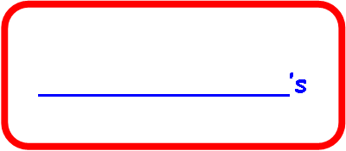

**___________’s**

**Nursery booklet**



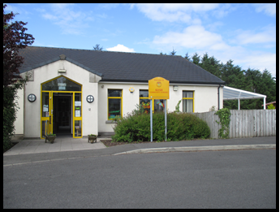

**I am going to**

**Kesh Community Nursery**

**I will wear yellow jumper like this one when I go to Nursery.**



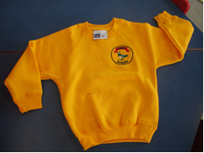



**Hello! My name is Mrs Parkinson and I am the Principal!**

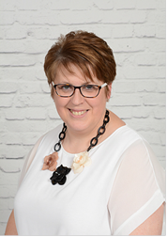

**Hello! My name is Mrs Read and I will be your new teacher!**

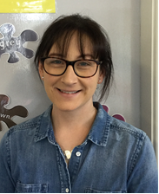

**Hello! My name is Mrs Curtis and I am your Nursery Assistant**

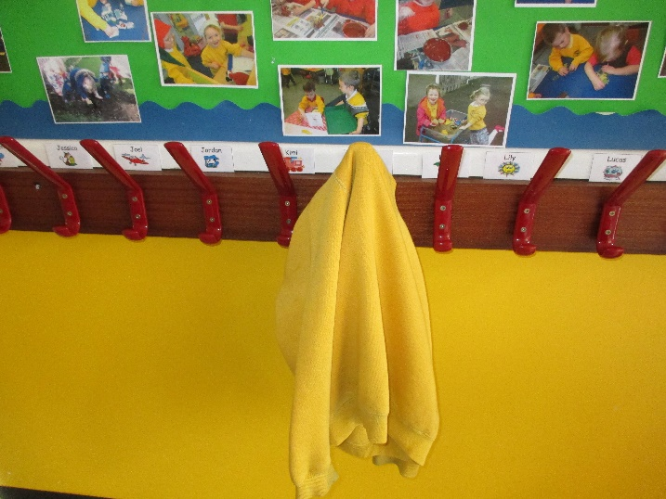

I will hang up my coat and bag on a peg. It has my name written on it.

**My name peg will look like this:**

**My name will be on the door too. I pick it off and put it on our ‘I’m here board’ and I will put it back on the door when I am going home.**

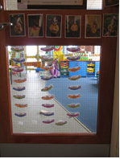

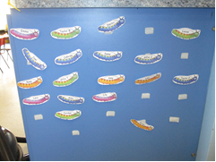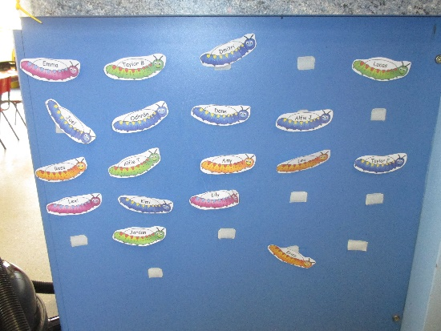



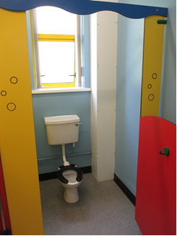

**This is the toilet in Nursery. It is just the right size for me.**

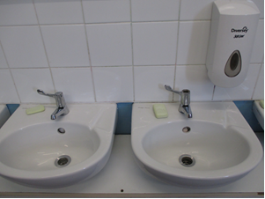

**This is where I will wash my hands.**

**Each boy and girl brings some fruit each day and we wash it and share it out with everyone**.

**Snack time!!**

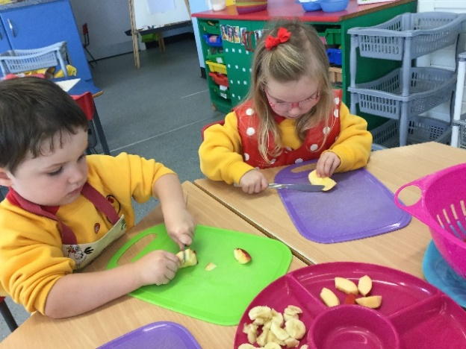

**First a group of boys and girls wash help prepare the snack and put out our cups and snacks.**

**Then I wait my turn for a snack necklace, then I wash and dry my hands**

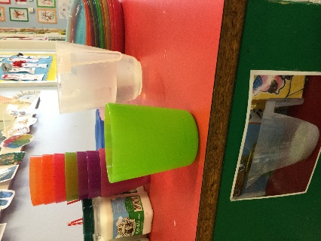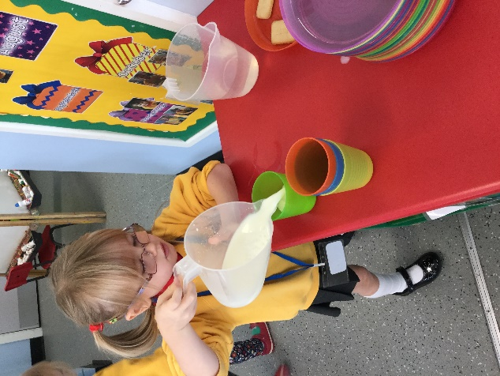

**After that I choose what I want to drink, pour it for myself and put it on the table.**

**Then I take down my photo and put it into a box before I collect my snack on my plate.**

**We try lots of different foods.**

**Sometimes we take snack outside too!**

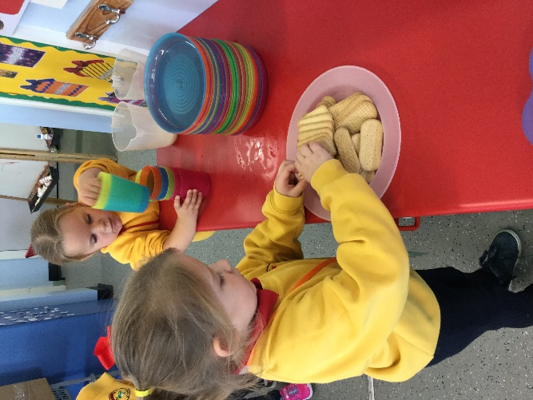

**When I am finished I put my cup and plate into the trolley and put my leftovers in the bin. Phew!!**

**Every day is very busy at Nursery …..and fun too!!**

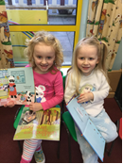

**We listen to stories…**

**……..and read and share books ourselves.**

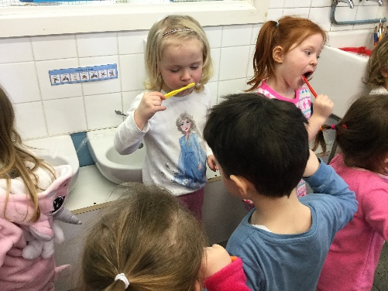

**Sometimes we get a bit messy but it’s great**

**fun!!**

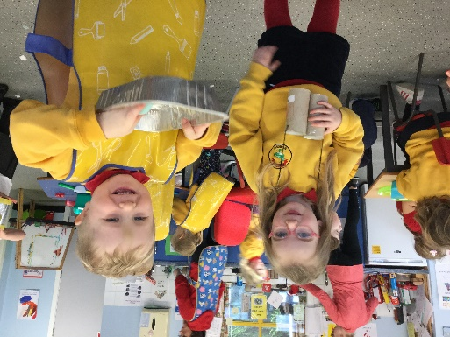

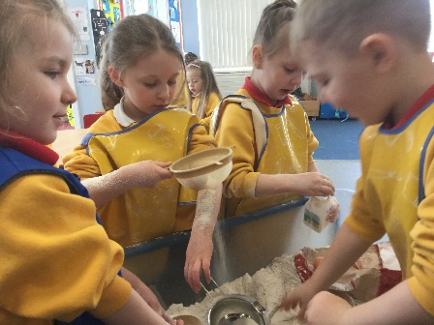

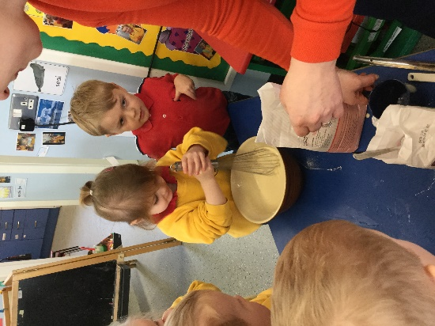

Sometimes we get a bit messy but it’s great fun!!

Sometimes we get a bit messy but it’s great fun!!

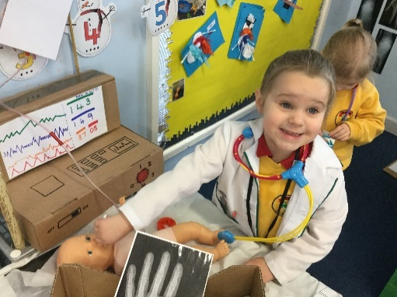

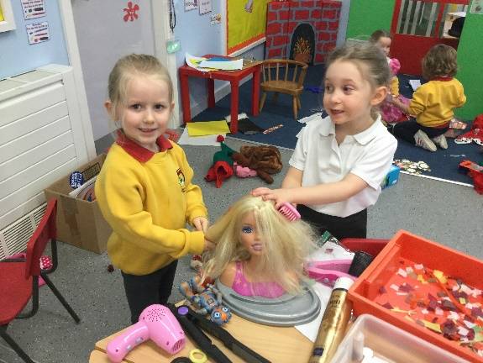

Sometimes we get a bit messy but it’s great fun!!

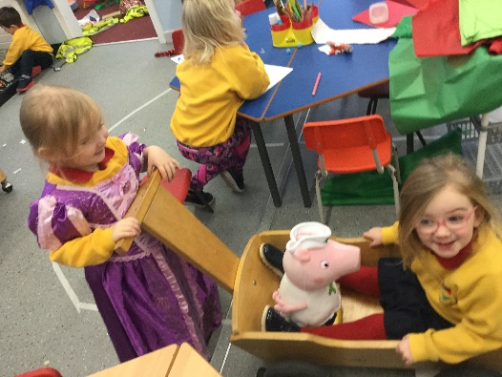

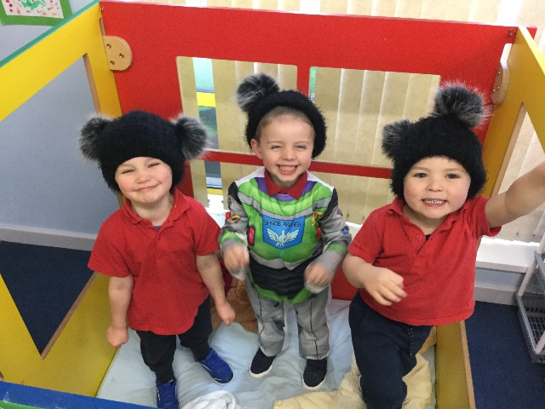

**We have fun in our role play area dressing up and becoming different people!**

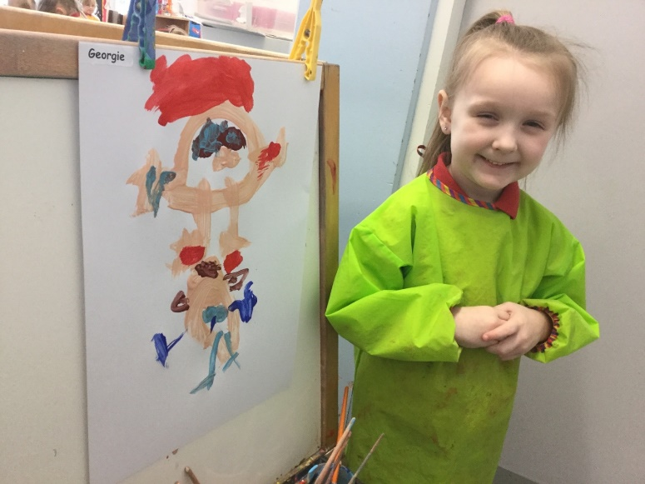

**We can paint. We always put on an apron to paint**.

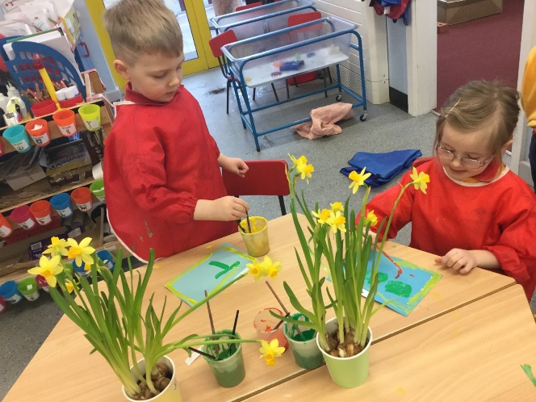

**We play in the sand and in the water. We always put on an apron to play in the water.**

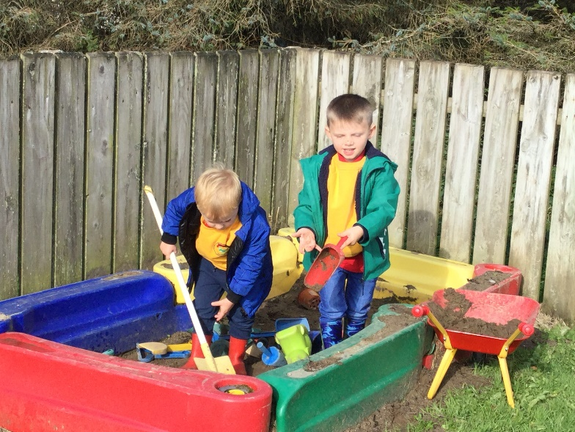

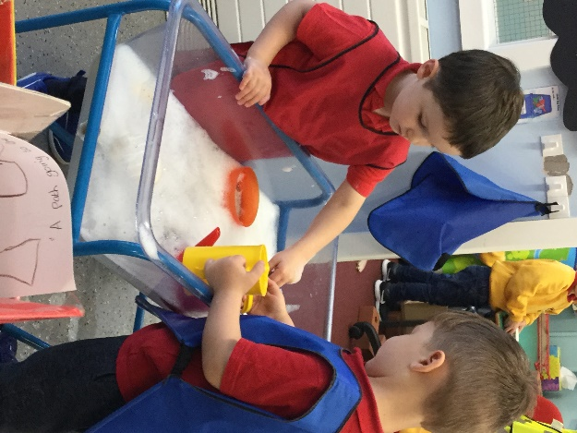

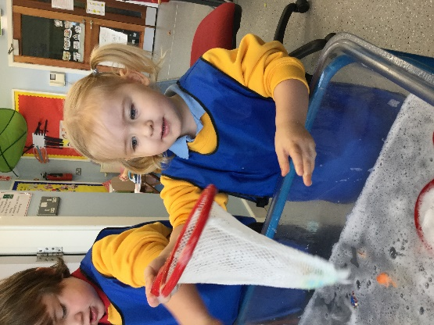

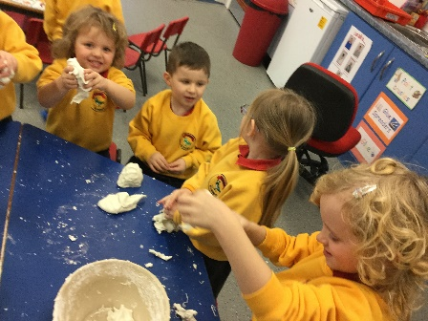

**We play with playdough. We make it in lots of different colours and even make it glittery sometimes!**

We can play with all the Nursery toys

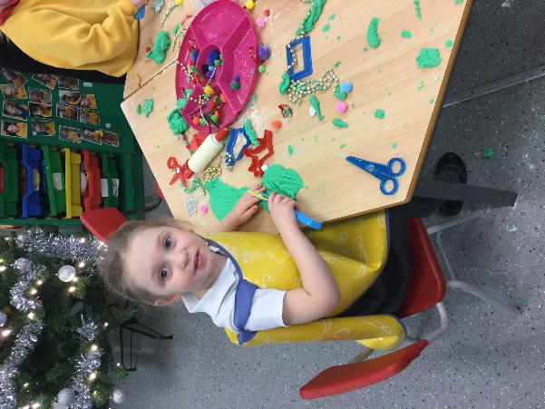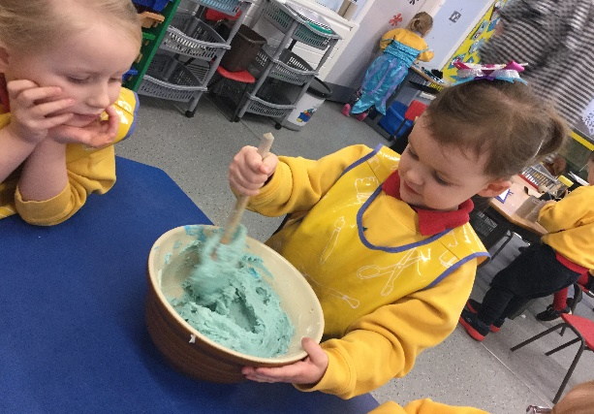

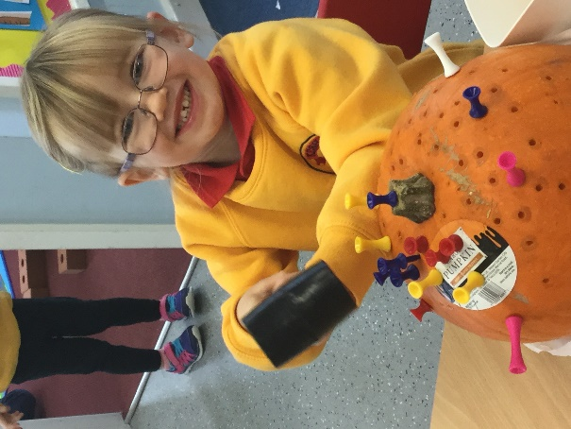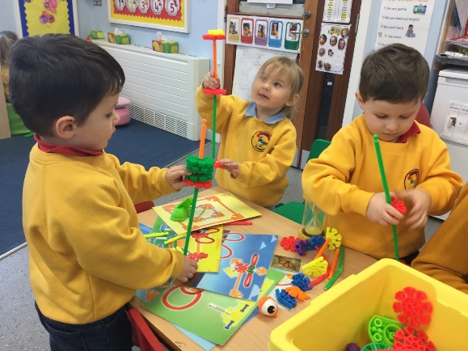

**We can build things and explore**

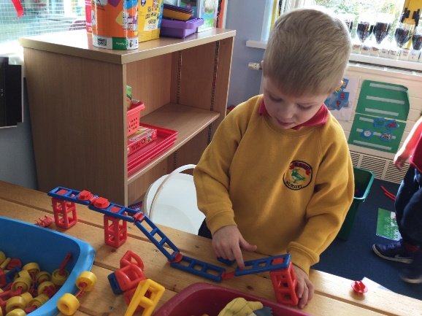

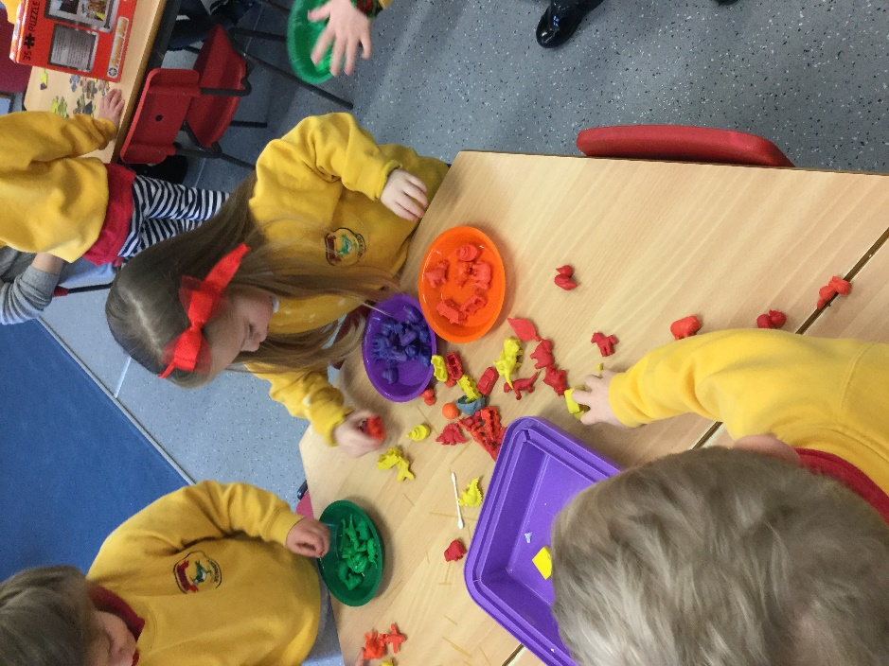

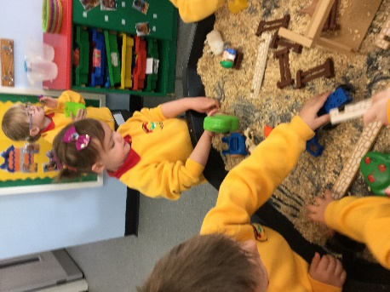

We can build things and explore

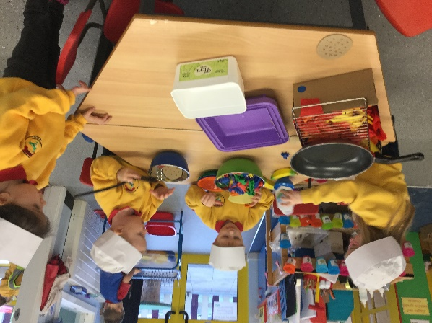

We can play with all the Nursery toys

**We can play with all the Nursery toys**

We can build things and explore

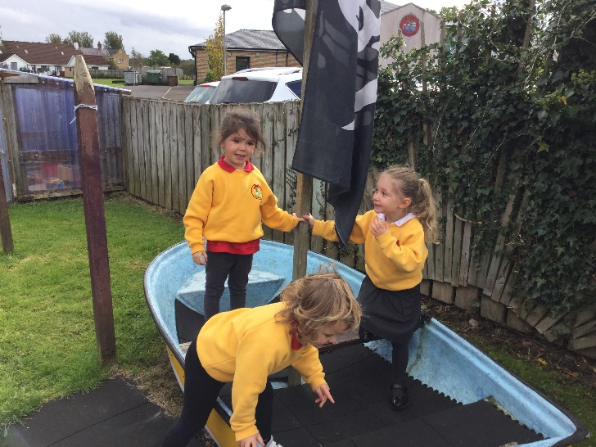

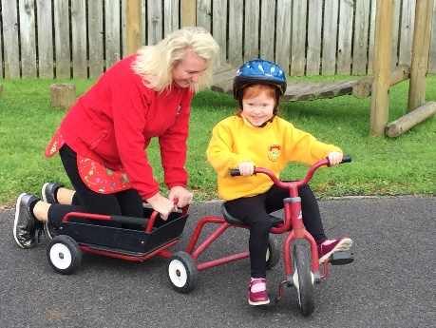

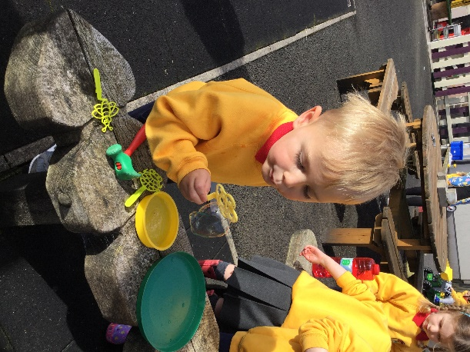

**We work and play outside. We can play with the bikes, on the slides, in the garden and in the play house. There’s lots to do!! When it’s wet we wear our wellies and coats.**

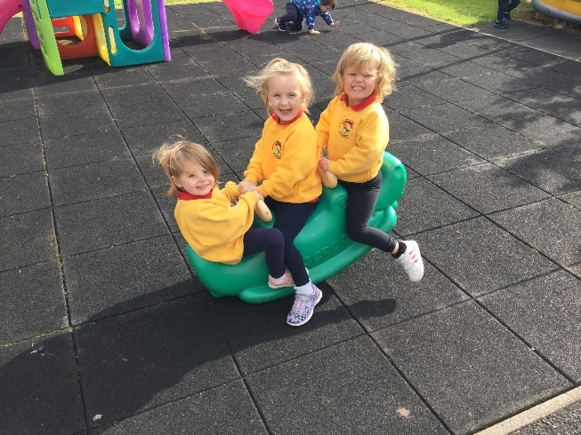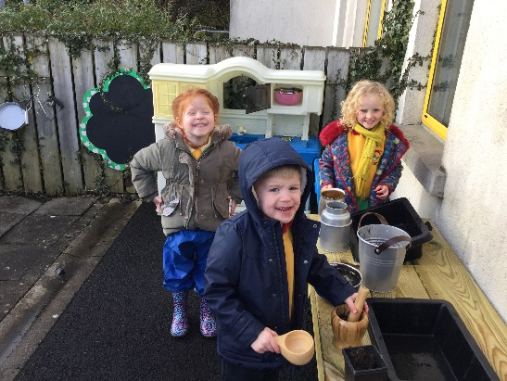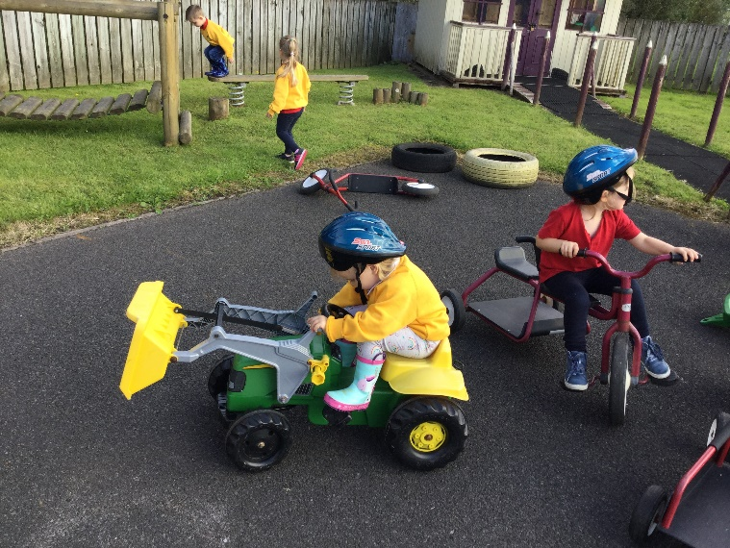

**When Nursery is over, we go home.**

**Can you draw a picture, or stick in a photograph of the person who will usually collect you from Nursery?**

**We can’t wait to meet you all in September!!!**

**Have a lovely summer!**

**Bye for now!**

***Mrs Curtis and Mrs Read***

***x***

