Student code report
Name: Year 7 Microbits
Date saved: Thu Mar 21 2024
Number of students: 24
User | Present this session | Session feedback
Teacher
Amy (1) | Present
Darragh (1) | Present
eli (1) | Present
Ella (1) | Present
Emily (1) | Present
faolan (1) | Present
Freya (1) | Present
Indie mae (1) | Present
jack (1) | Present
Jenson (1) | Present
Jessica (1) | Present
karter (1) | Present
Katie (1) | Present
Kelsey (1) (1) | Present
Lily (1) | Present
lucas (1) | Present
Lucas B (1) | Present
lucy (1) | Present
Luke (1) (1) | Present
molly (1) | Present
nathan (1) | Present
olly (1) | Present
Oscar Loane (1) | Present
sam (1) | Present

Teacher
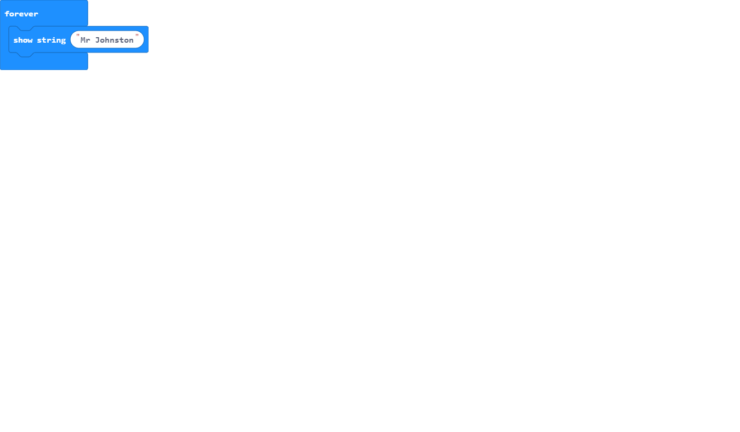

Amy (1)
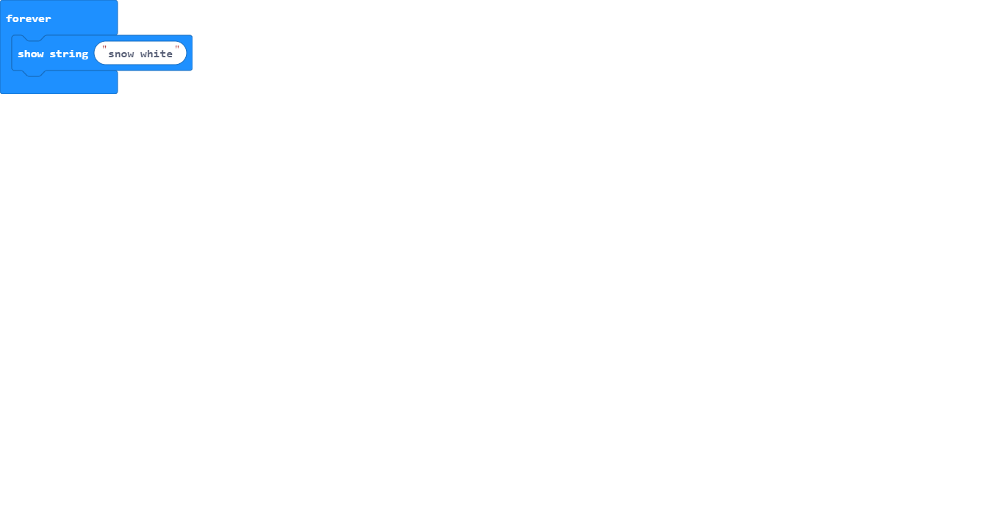

Darragh (1)
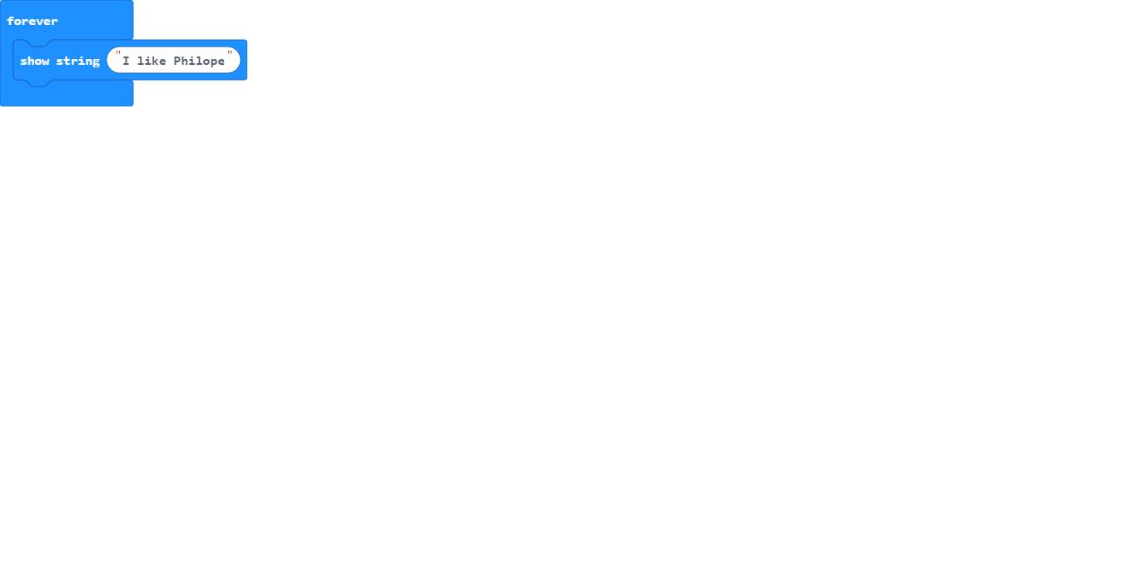

eli (1)
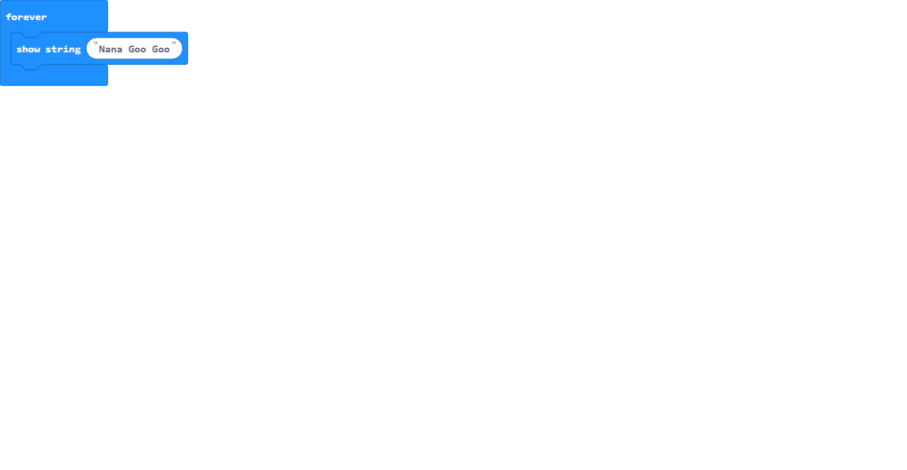

Ella (1)
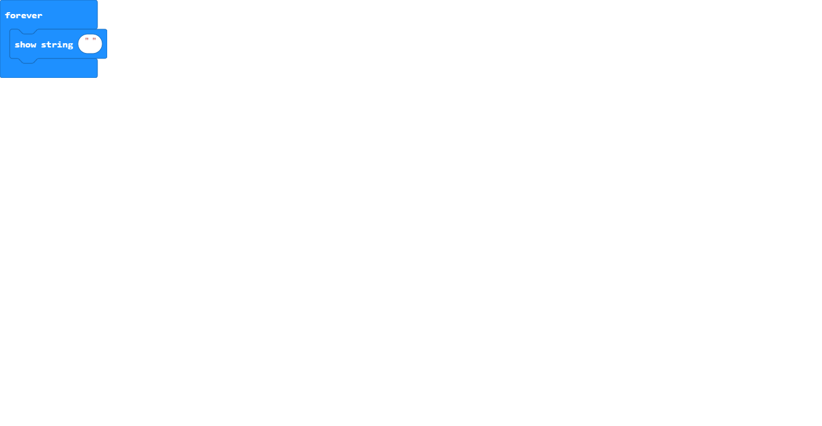

Emily (1)
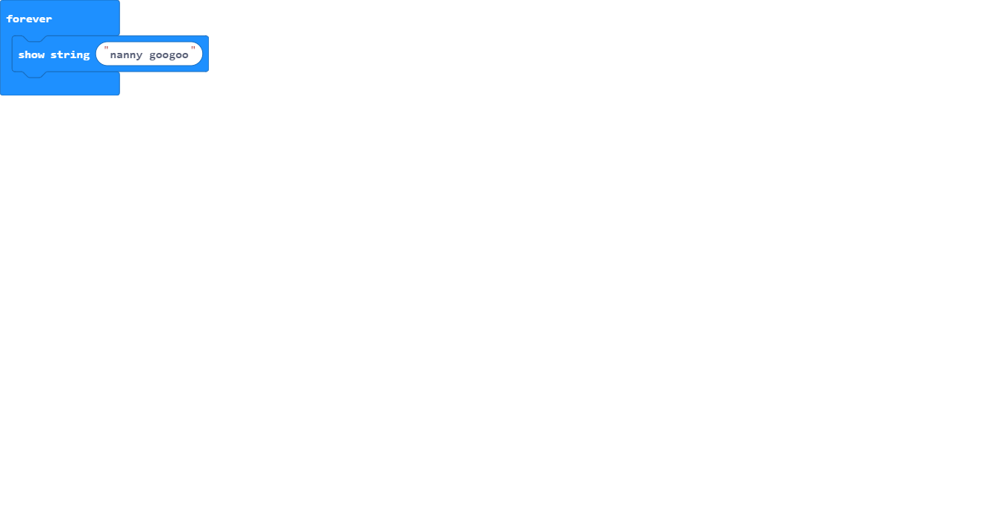

faolan (1)

Freya (1)
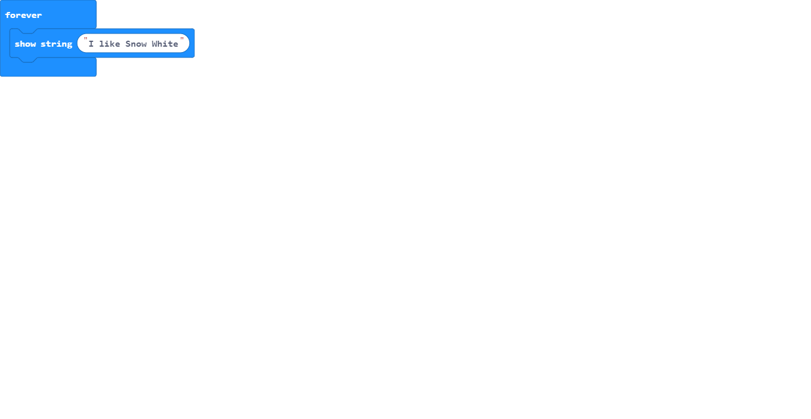

Indie mae (1)
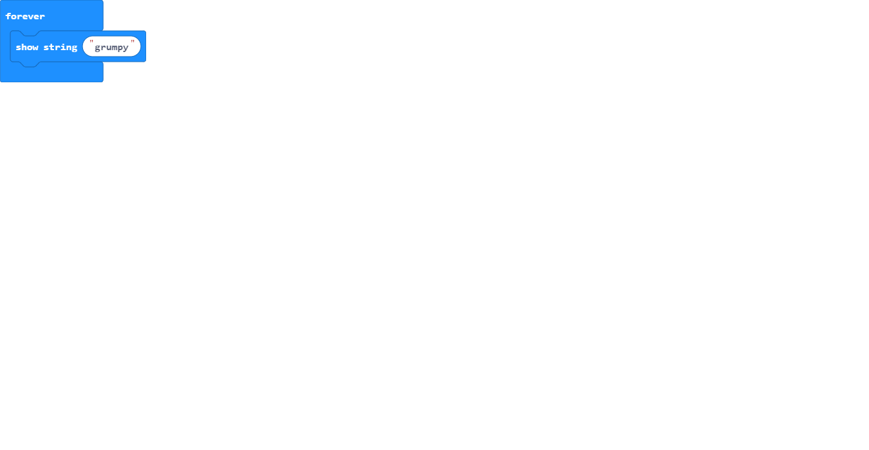

jack (1)
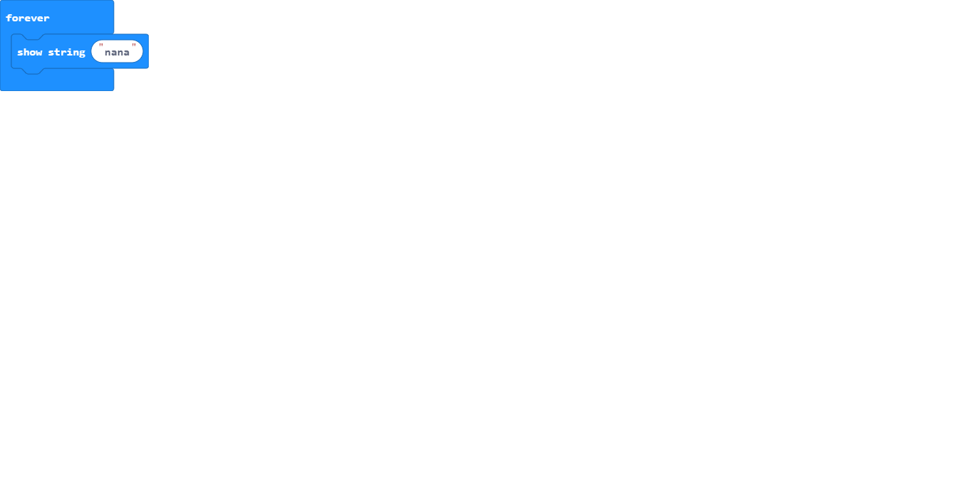

Jenson (1)
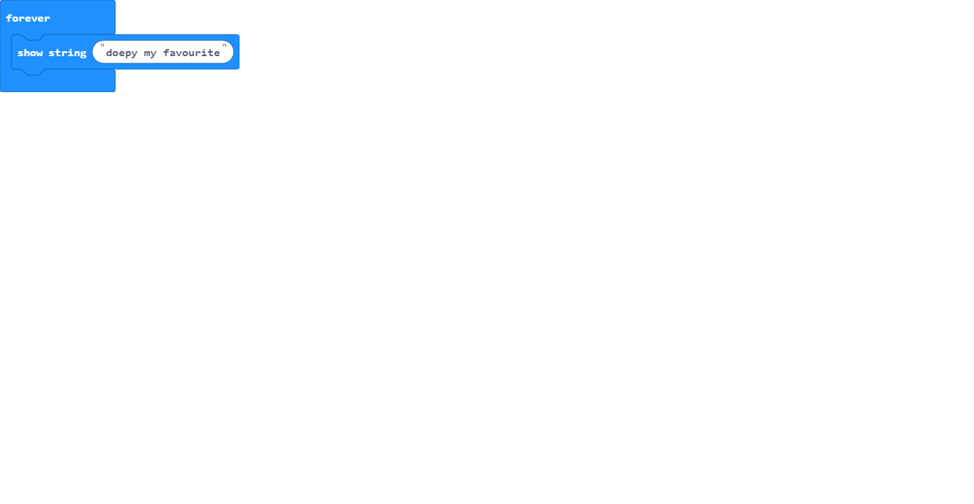

Jessica (1)
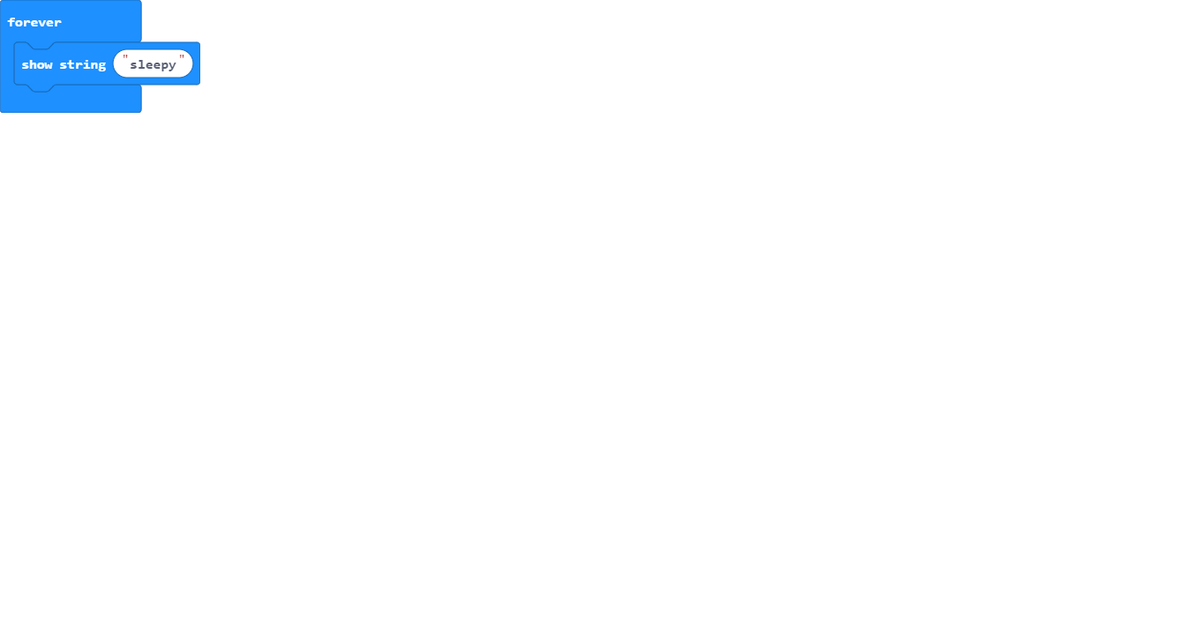

karter (1)
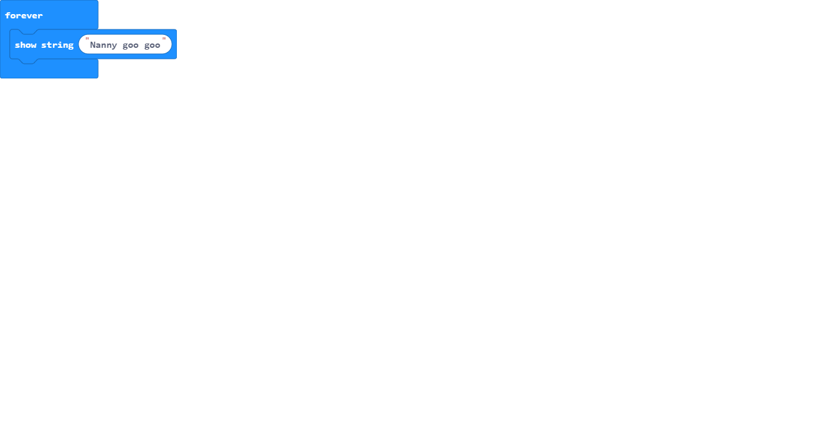

Katie (1)
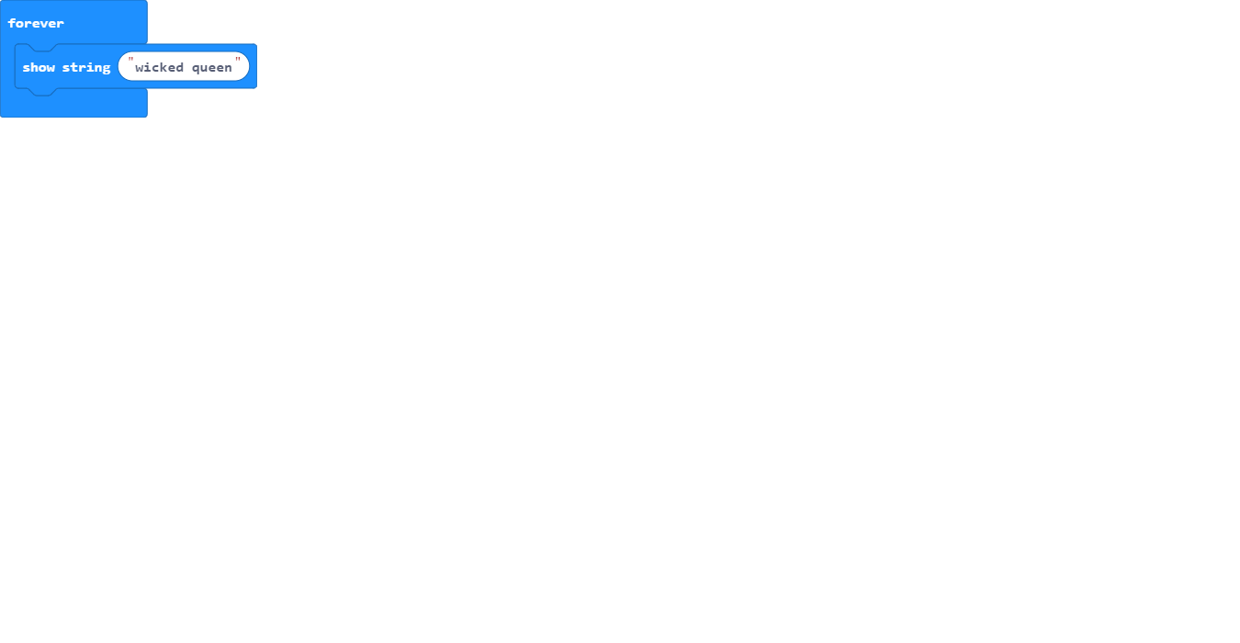

Kelsey (1) (1)
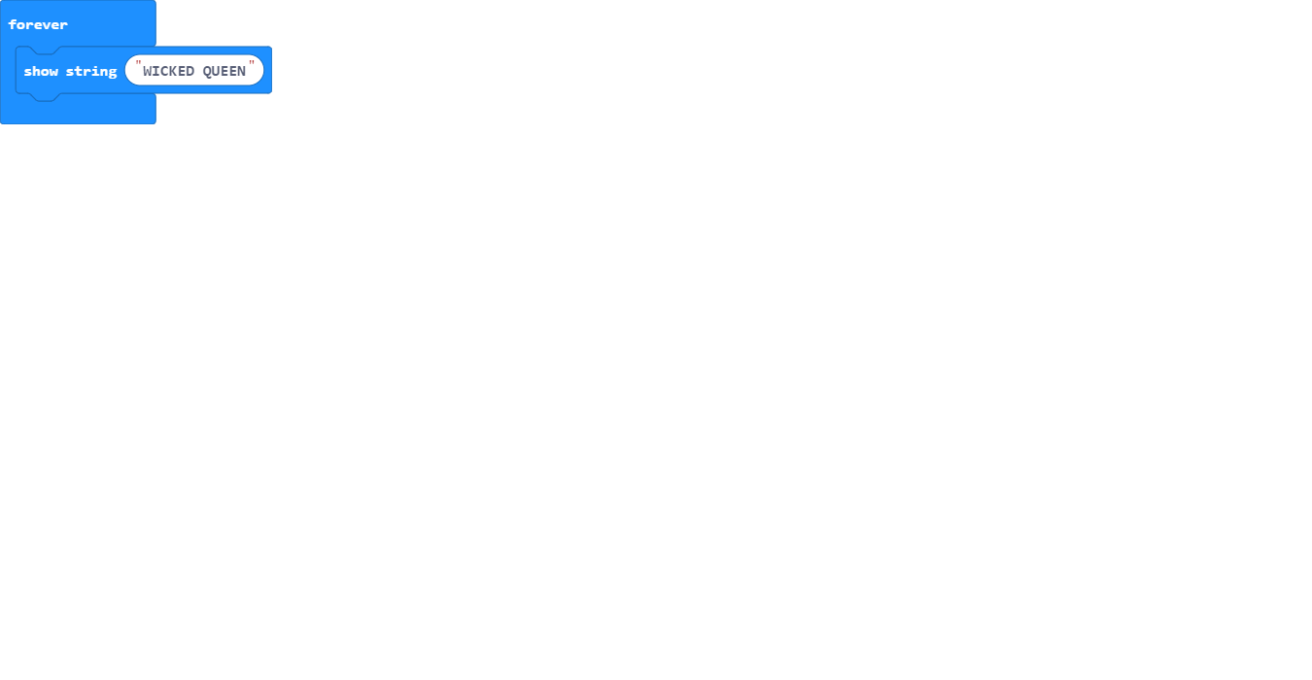

Lily (1)

lucas (1)
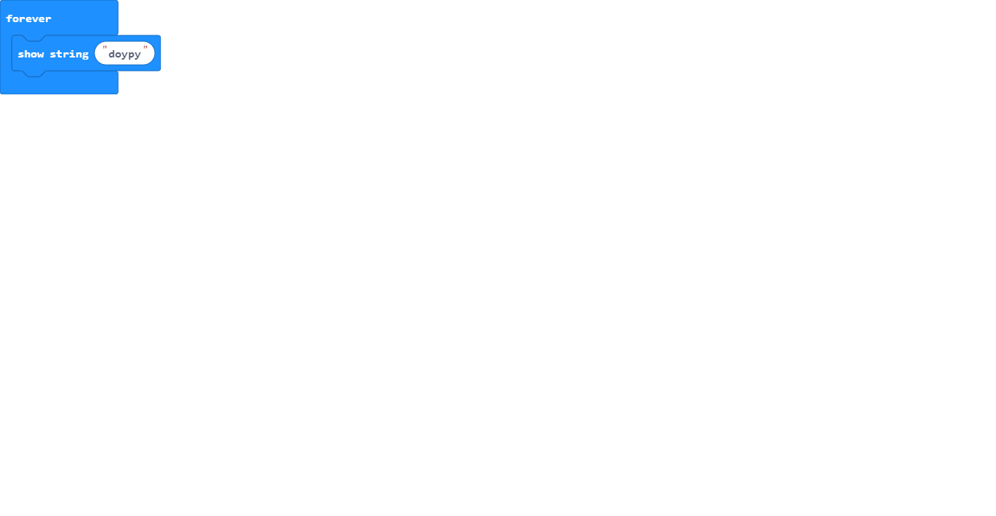

Lucas B (1)
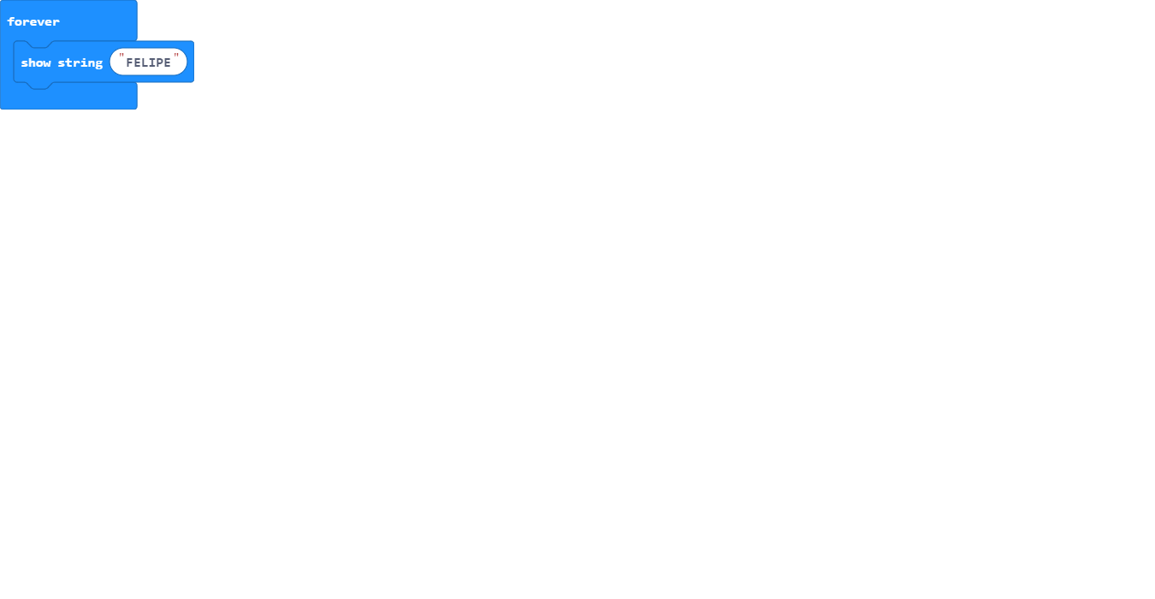

lucy (1)
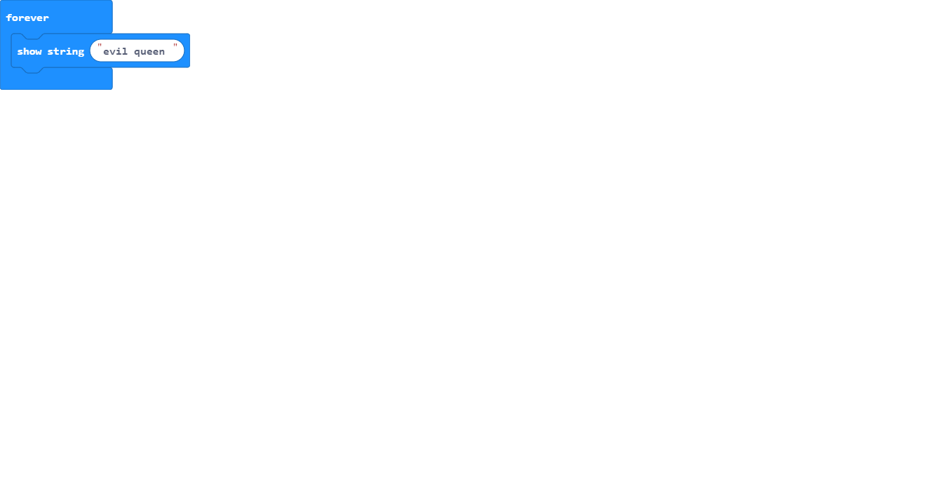

Luke (1) (1)
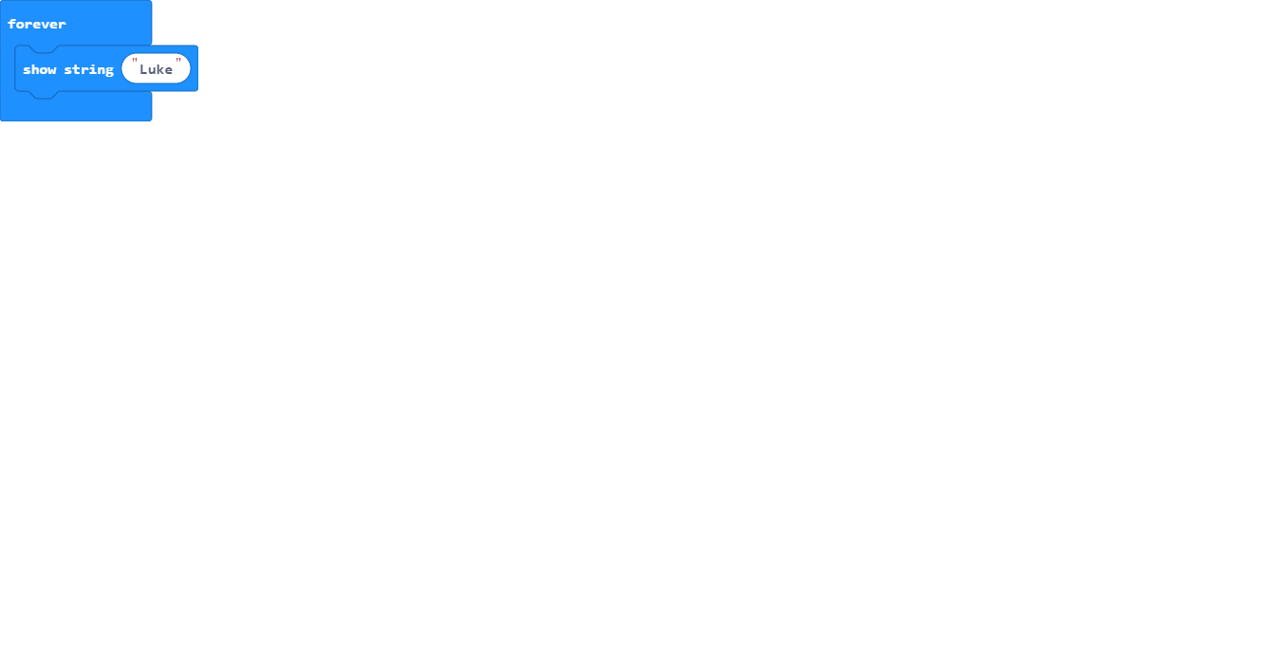

molly (1)

nathan (1)
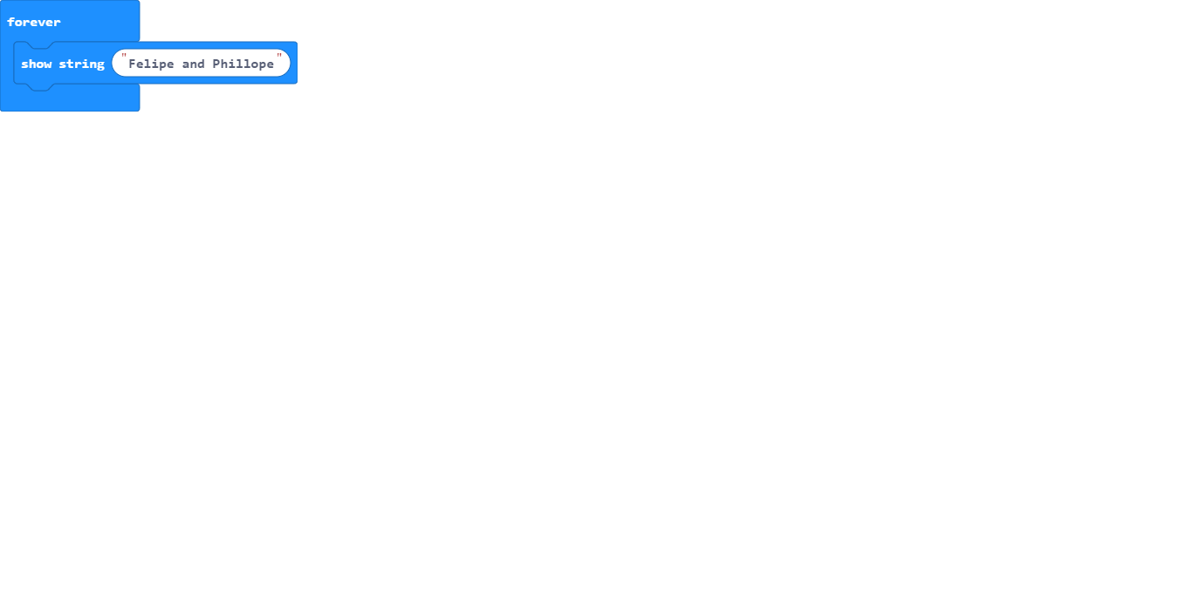

olly (1)

Oscar Loane (1)
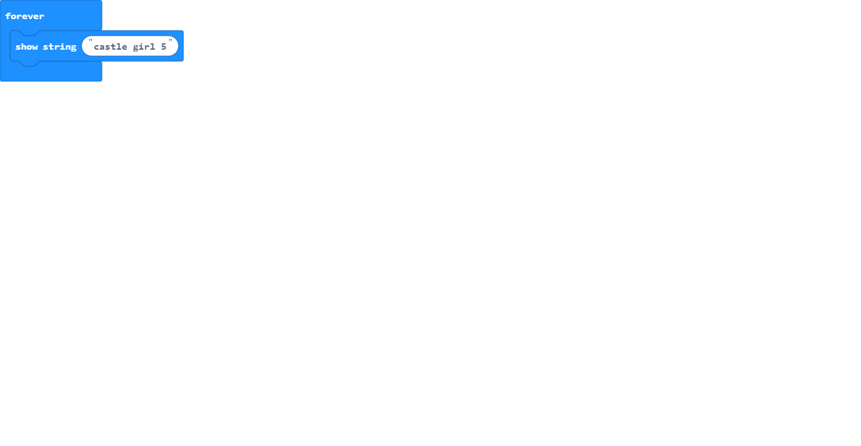

sam (1)

